|  |
| --- |
| EPAM Systems, RD Dep.  MTN.*NIX.07 Oracle DB. Introduction to DWH |
| MTN.*NIX.07 Labs - Access and Join Methods Part 2 |

|  |  |  |  |  |  |
| --- | --- | --- | --- | --- | --- |
| REVISION HISTORY | | | | | |
| Ver. | Description of Change | Author | Date | Approved | |
| Name | Effective Date |
| 1.0 | Initial status of document | [**Kiryl Bucha**](mailto:Kiryl_bucha@epam.com) | 16-JAN-2012 |  |  |
|  |  |  |  |  |  |

*Contents*

1. Auto Trace & Explain Plan 3

1.1. Task 1: Auto Trace configuration training 3

2. Join Methods 3

2.1. Task 2: Nested Loops Joins 4

2.2. Task 3: Sort-Merge Joins 4

2.3. Task 4: Hash Joins 4

2.4. Task 5: Cartesian Joins 4

2.5. Task 6: Left/Right Outer Joins 4

2.6. Task 7: Full Outer Join 4

2.7. Task 8: Semi Joins 4

2.8. Task 9: Anti Joins 5

2.9. Task 10: Prepare summary table 5

# Auto Trace & Explain Plan

# Join Methods

## Task 2: Nested Loops Joins

SELECT * */*+ USE_NL(e d) */*

FROM emp e, dept d

WHERE E.DEPTNO = D.DEPTNO

and E.COMM between 1 and 100;

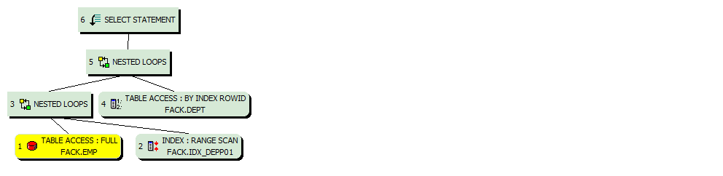

## Task 3: Sort-Merge Joins

SELECT * */*+ USE_MERGE(e d) */*

FROM emp e, dept d

WHERE E.DEPTNO = D.DEPTNO;

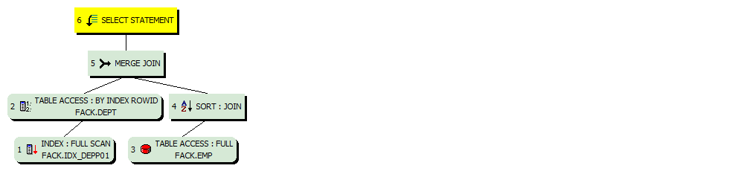

## Task 4: Hash Joins

SELECT DISTINCT * */*+ USE_HASH(e d) */*

FROM emp e, dept d

WHERE E.DEPTNO = D.DEPTNO

and E.EMPNO >100;

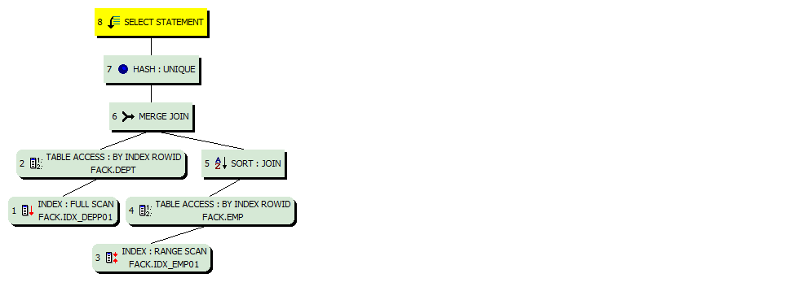

## Task 5: Cartesian Joins

SELECT */*+ USE_HASH(t1 t2) */* distinct *

FROM t3 t1, t4 t2*/*+ USE_HASH(t1, t2) */*

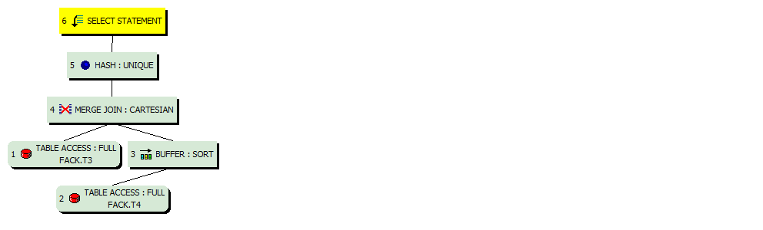

## Task 6: Left/Right Outer Joins

SELECT */*+ use_nl(t3 t4) */* *

FROM t3 left join t4 on T3.ID = T4.ID

where T3.T_PAD !=T3.ID/5

order by 1;

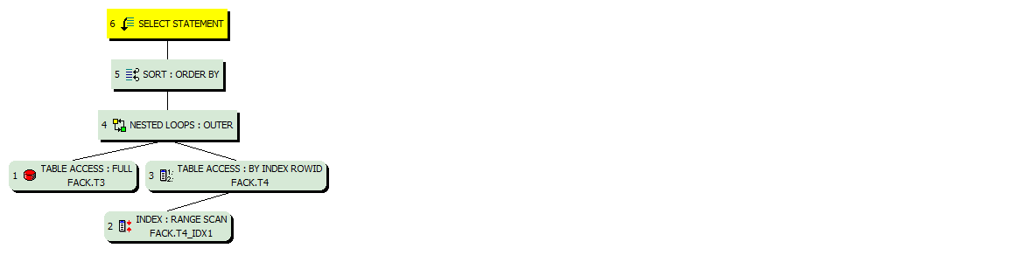

## Task 7: Full Outer Join

SELECT */*+ use_nl(t3 t4) */* *

FROM t3 full join t4 on T3.ID = T4.ID

where T3.T_PAD !=T3.ID/5

order by 1;



## Task 8: Semi Joins

SELECT *

FROM t3

WHERE t3.id IN

( SELECT id FROM t4 );

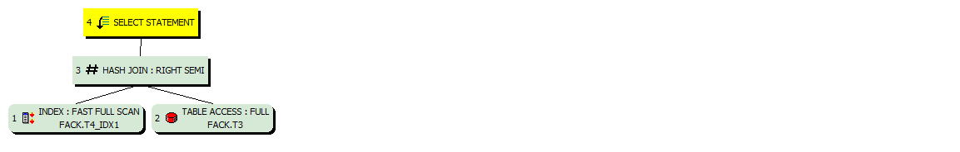

**Note:**  If you would like change in execution plan the type of join method use oracle performance hints.

1. SEMIJOIN – perform a semi-join (the optimizer gets to pick which kind)
2. NO_SEMIJOIN – obviously means don’t perform a semi-join
3. NL_SJ – perform a nested loops semi-join (deprecated as of 10g)
4. HASH_SJ – perform a hash semi-join (deprecated as of 10g)
5. MERGE_SJ – perform a merge semi-join (deprecated as of 10g)

## Task 9: Anti Joins

SELECT *

FROM t3

WHERE t3.id not IN

( SELECT id FROM t4 );

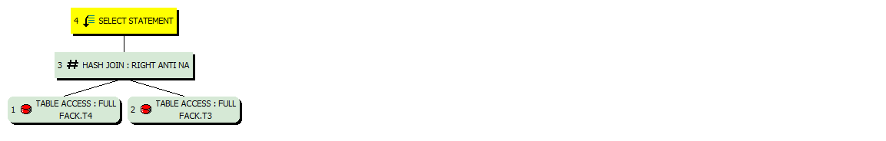

## Task 10: Prepare summary table

**Task:** Make comparison of all possible variant of join methods and join access methods and fill the table below:

|  |  |  |  |  |  |  |
| --- | --- | --- | --- | --- | --- | --- |
| Join Access “A” | Join Access “B” | Nested Loop | Hash Join | Sort-Merge Join | Anti-Join | Semi-Join |
| Small Table | Small Table |  |  |  |  |  |
| Small Table | Indexed Small Table |  |  |  |  |  |
| … |  |  |  |  |  |  |